There are multiple ways to create notebook, I Initially launched an EMR cluster.

In the next step we need to create an studio and then create a workspace (Notebooks).

Launching jupyter from the notebook.

Pyspark practice in jupyter notebook.

Running pyspark commands on putty :

Join examples:

Reading data from csv s3 ..

Reading a csv file from s3 bucket and displaying data in it and performing few operations.

Showing the male candidates ..

Female candidates...

Performing union operation , combining 2 csv files.

Checking for duplicates if any after combining the 2 files.

Write back to the s3 bucket----

Reading a txt file from s3 ---

Searching for a particular word from the txt file and checking how many times it has repeated.

Reading a Json file from s3 ..

In the below example we are reading a car sales report and performing some analysis ..

Using FILTER extracted only the BMW from the Brand column.

Using group by command we displayed all the 7 brands and their average price of their cars.

Using COUNT checking how many cars were sold by each brand.

Adding a new column as updated date

Writing back to the S3 bucket.

Count distinct is used to count the no of car companies in the brand column.

Broadcast join sample example: It is used when 2 data frames or RDD’s are joining where one of it is a large data set than the other, here instead of distributing the smaller DataFrame across the cluster, Spark broadcasts it to all the worker nodes. This reduces data shuffling and network overhead, as the larger DataFrame can be joined with the smaller one locally on each worker node.

Accumulators are variables in Spark used for aggregating information across worker nodes. They allow you to perform calculations and update their values in a distributed manner.

Data skew : Data skew refers to an imbalanced distribution of data across partitions in a distributed system. In the context of Apache Spark, data skew can negatively impact performance, as some worker nodes may be overloaded while others are underutilized. This leads to longer processing times and inefficient resource utilization.

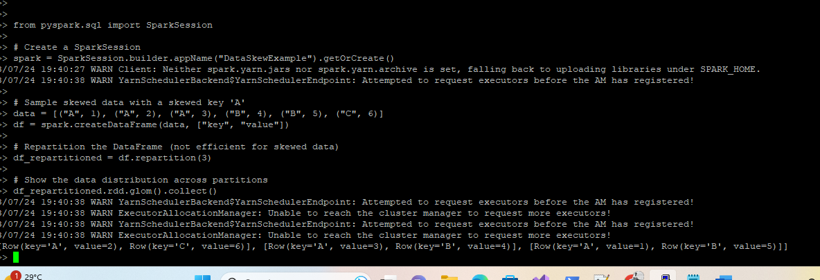

df.cache(): the DataFrame **df** is cached in memory using **df.cache()** after reading from S3. Subsequent operations like filtering and grouping are performed on the DataFrame, and when you call actions like **show()**, Spark will use the cached data to reduce recomputation time.

df.persist() : the DataFrame **df** is persisted to disk using **df.persist()**. By default, it uses the **MEMORY_AND_DISK** storage level. Subsequent operations on the DataFrame access the persisted data from disk when calling actions like **show()**, reducing recomputation time.

Caching in memory is faster, but it consumes more memory, so it's essential to balance your memory requirements and the size of the DataFrame you are working with. Additionally, make sure to call **unpersist()** when you are done with the cached or persisted DataFrame to release the memory or disk space.



Submitting a simple “hello world” spark-submit job:

Redaing a file from s3 and performing filter operations and writing back to s3 using spark-submit .



